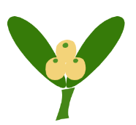

Declaration
Please accept for publication the article entitled:
....................................................................................................................................................................
....................................................................................................................................................................
....................................................................................................................................................................
...................................................................................................................................................................
to the journal HERBALISM. I declare that this work has not been published anywhere, nor has it been submitted to another publisher. I hereby transfer the copyright in the above-mentioned article to the publisher free of charge. The transfer applies to all fields of use (print, electronic files and media, Internet, fields as defined in Article 50 of the current Act on Copyright and Related Rights of 4 February 1994, as amended). I hereby transfer to the Publisher all dependent copyrights to the said article, in particular to its elaboration in the form of abstracts, translations, abridgements etc.
I hereby declare that the above-mentioned article is an original work and that it does not infringe on the copyrights of other persons, also with regard to the illustrative material (photographs, drawings, charts, and tables). I declare under legal responsibility that, in the event that there are co-authors, I have unlimited power of attorney to dispose of their material copyright in the scope of this article, which I also transfer to the Publisher.

Krosno, on ....................... Author’s signature

